Working with Numerical Data
Categorical Data - Features having a specific set of possible values
Numerical Data - Features represented as integers or real-valued numbers
How a Model Ingests Data with Feature Vectors
Binning - A feature engineering technique that groups different numerical subranges into bins (or buckets); also called bucketing. In many cases, binning turns numerical data into categorical data
Bucketing - Converting a single feature into multiple binary features called buckets or bins, typically based on a value range
Feature Engineering - A process that involves the following steps:
- Determining which features might be useful in training a model.
- Converting raw data from the dataset into efficient versions of those features.
Feature Vector - The array of feature values comprising an example. The feature vector is input during training and during inference
Normalization - Broadly speaking, the process of converting a variable’s actual range of values into a standard range of values, such as:
- -1 to +1
- 0 to 1
- Z-scores (roughly, -3 to +3)
Preprocessing - Processing data before it’s used to train a model
First Steps
Clipping - A technique for handling outliers by doing either or both of the following:
- Reducing feature values that are greater than a maximum threshold down to that maximum threshold.
- Increasing feature values that are less than a minimum threshold up to that minimum threshold.
Outliers - Values distant from most other values in a feature or label
Programming Exercises
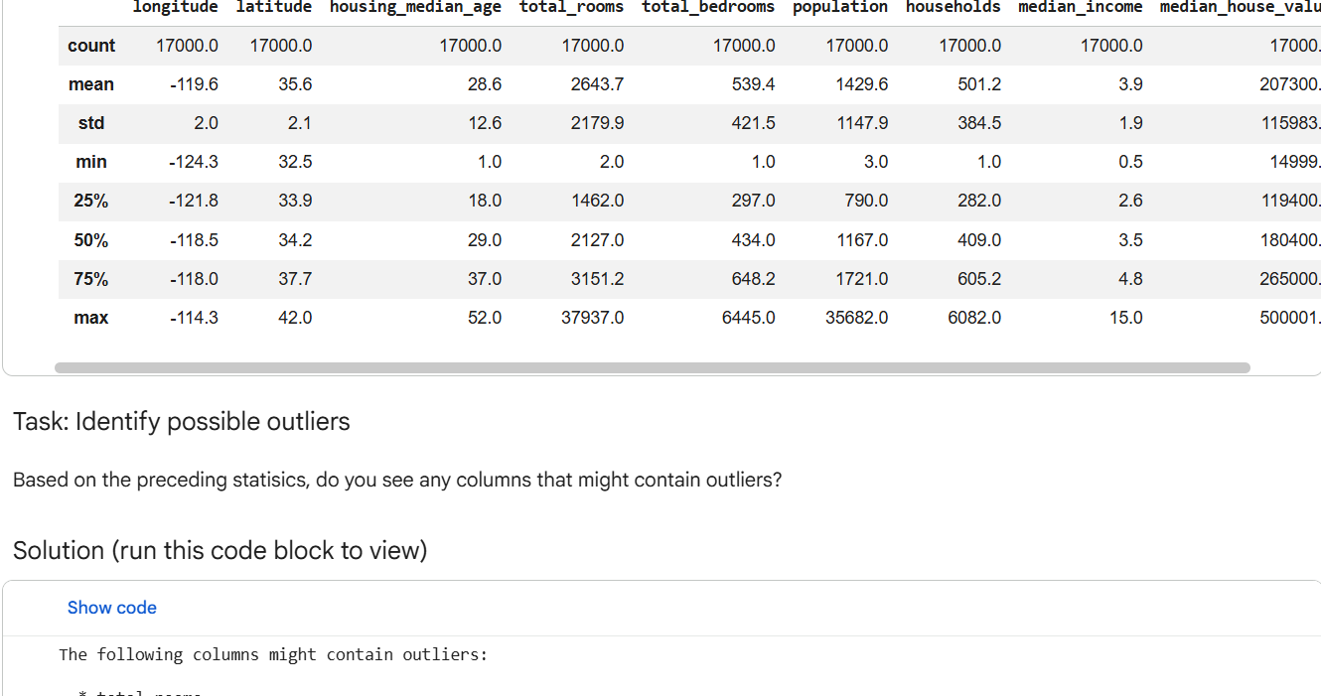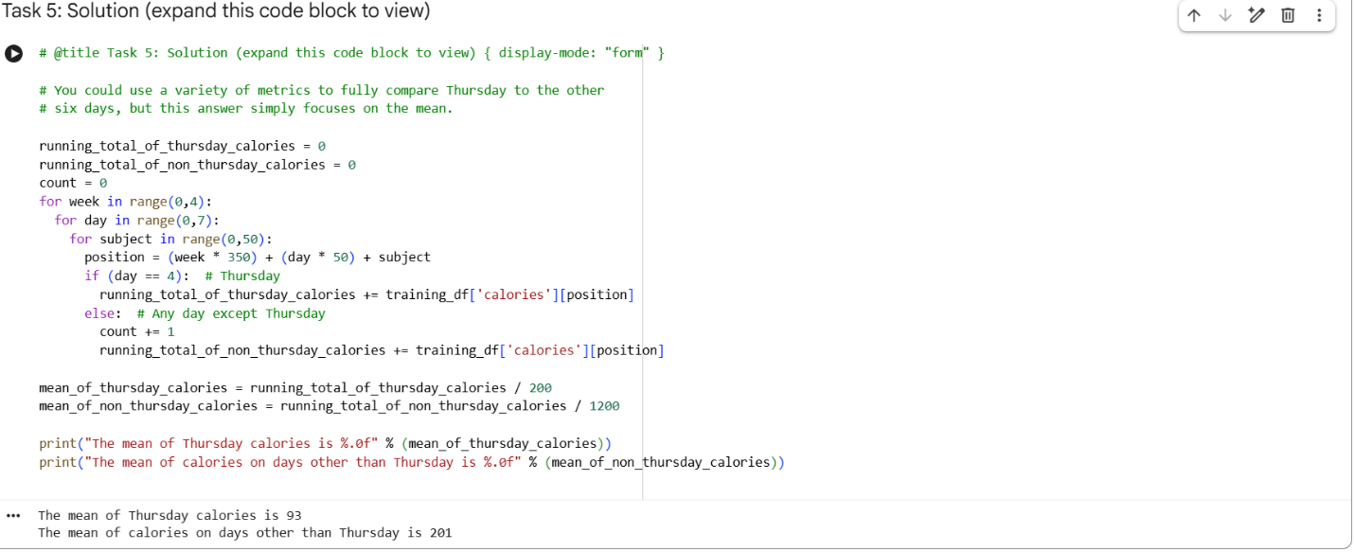

Normalization
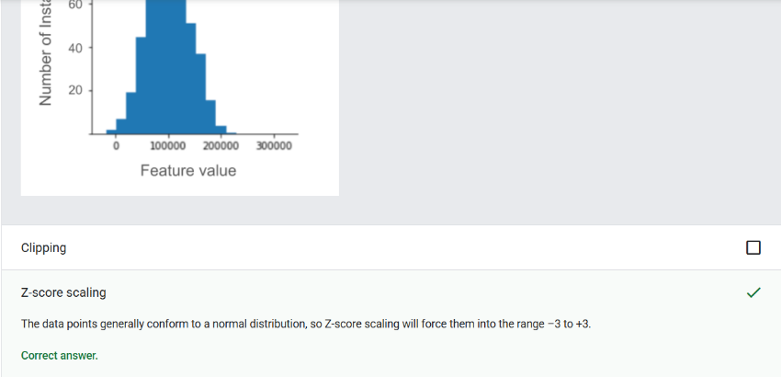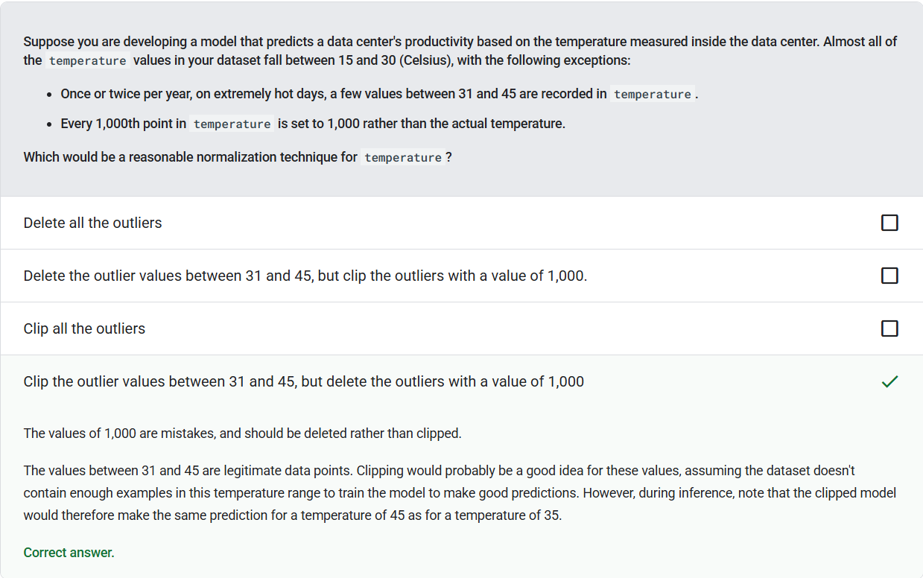
Clipping - A technique for handling outliers by doing either or both of the following:
- Reducing feature values that are greater than a maximum threshold down to that maximum threshold.
- Increasing feature values that are less than a minimum threshold up to that minimum threshold.
NaN Trap - When one number in your model becomes a NaN during training, which causes many or all other numbers in your model to eventually become a NaN. NaN is an abbreviation for “Not a Number.”
Normalization - Broadly speaking, the process of converting a variable’s actual range of values into a standard range of values, such as:
- -1 to +1
- 0 to 1
- Z-scores (roughly, -3 to +3)
Scaling - Converting floating-point values from their natural range into a standard range, usually 0 to 1 or -1 to +1
Z-score Normalization - Representing a feature by its Z-score (the number of standard deviations a value is from the mean) and storing that Z-score in the feature vector, calculated as x’ = (x - μ) / σ
Binning
Binning - A feature engineering technique that groups different numerical subranges into bins (or buckets); also called bucketing. In many cases, binning turns numerical data into categorical data
Bucketing - Converting a single feature into multiple binary features called buckets or bins, typically based on a value range
Clipping - A technique for handling outliers by doing either or both of the following:
- Reducing feature values that are greater than a maximum threshold down to that maximum threshold.
- Increasing feature values that are less than a minimum threshold up to that minimum threshold.
Feature - An input variable to a machine learning model. An example consists of one or more features
Feature Engineering - A process that involves the following steps:
- Determining which features might be useful in training a model.
- Converting raw data from the dataset into efficient versions of those features.
Feature Vector - The array of feature values comprising an example. The feature vector is input during training and during inference
Label - In supervised machine learning, the “answer” or “result” portion of an example
Scaling - Converting floating-point values from their natural range into a standard range, usually 0 to 1 or -1 to +1
Qualities of Good Numerical Features
Outliers - Values distant from most other values in a feature or label
Feature - An input variable to a machine learning model. An example consists of one or more features
Feature Vector - The array of feature values comprising an example. The feature vector is input during training and during inference
Polynomial Transforms
Categorical Data - Features having a specific set of possible values
Feature - An input variable to a machine learning model. An example consists of one or more features
Feature Cross - A synthetic feature formed by “crossing” categorical or bucketed features
Gradient Descent - A mathematical technique to minimize loss. Gradient descent iteratively adjusts weights and biases, gradually finding the best combination to minimize loss
Linear Regression - A type of machine learning model in which both of the following are true:
- The model is a linear model.
- The prediction is a floating-point value. (This is the regression part of linear regression.)
Synthetic Feature - A feature not present among the input features, but assembled from one or more of them. Methods for creating synthetic features include the following:
- Bucketing a continuous feature into range bins.
- Creating a feature cross.
- Multiplying (or dividing) one feature value by other feature value(s) or by itself.
Weight - A value that a model multiplies by another value. Training is the process of determining a model’s ideal weights
Test Your Knowledge


